Grommets

What are grommets?
Grommets are very small plastic tubes, which sit in a hole in the eardrum. They let air get in and out of the ear. This keeps the ear healthy
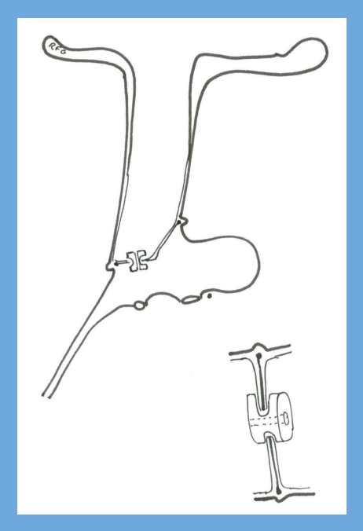

Why do we use grommets?
Some people get fluid behind the eardrum. This is sometimes called ‘glue ear’. It is very common in young children, but it can happen in adults too. We don’t know exactly what causes glue ear.
Most young children will have glue ear at some time, but it doesn’t always cause problems. We only need to treat it if it is causing problems with hearing or speech, or if it is causing lots of ear infections.

How are grommets put in?
The grommets are placed in the eardrum under a short general anaesthetic and the procedure is usually performed as a day case admission to hospital. The operation is carried out down the ear canal so there are no cuts to see on the outside of the ear. A small opening is made in the eardrum using a microscope to magnify the area and the fluid is sucked out of the ear with a fine sucker. The grommet is then placed in the opening in the eardrum. The procedure takes between ten and twenty minutes.

How long do grommets stay in for?
Grommets fall out by themselves as the eardrum is constantly growing. They may stay in for six months, or a year, or sometimes even longer in older children. You may not notice when they drop out.

Does my child have to have grommets?
Glue ear tends to get better by itself, but this can take a while. We like to leave children alone for the first three months, because about half of them will get better in this time. After three months, we will see your child again and decide whether we need to put in grommets.
If the glue ear is not causing any problems, we can just wait for it to settle by itself. If it is causing problems with poor hearing, poor speech or lots of infections, it may be better to put grommets in.
If we do put in grommets, the glue ear may come back when the grommet falls out. This happens to one child out of every three who has grommets put in. We may need to put more grommets in to last until your child grows out of the problem.
You may change your mind about the operation at any time, and signing a consent form does not mean that your child has to have the operation.
If you would like to have a second opinion about the treatment, you can ask your specialist. He or she will not mind arranging this for you.
You may wish to ask your own GP to arrange a second opinion with another specialist.

What are the alternatives to grommets?
Steroid nasal sprays may help some children if they have nasal allergy; Congestion in the nose caused by allergy may affect the normal function of the nose and ears. Antibiotics, antihistamines and decongestants do not help this type of ear problem. Alternative treatments, such as cranial osteopathy are not helpful.
Using a nasal balloon to open the tube to the ear may help older children if used regularly.
Taking out the adenoids may help the glue ear get better, and your surgeon may want to do this at the same time as putting grommets in.
A hearing aid can sometimes be used to treat the poor hearing and speech problems that are caused by glue ear. This would mean that your child would not need an operation.

Can I do anything to help my child?
Speak clearly, and wait for your child to answer. Make sure he or she can see your face when you speak. Call your child’s name to get them to look at you before you speak. Let nursery and schoolteachers know that your child has a hearing problem. It may help for your child to sit at the front of the class.

Are grommets sore?
Grommets are not usually sore at all. You can give your child simple painkillers (e.g. paracetamol or ibuprofen) if you need to. Grommets should improve your child’s hearing straight away. Some children think everything sounds too loud until they get used to having normal hearing again. This usually takes only a few days.

What about ear infections?
Most people with grommets do not get any ear infections. If you see yellow fluid coming out of the ear, it may be an infection. It will not be as sore as a normal infection, and your child won’t be as ill. In this situation we advise you to take your child to see your GP. If you get some antibiotic ear drops from your GP doctor, the problem will quickly settle. Some doctors may give antibiotics by mouth instead of antibiotic ear drops. Ask your GP or ENT doctor for help if infections become troublesome.

Can my child swim with grommets in?
Your child can start swimming a couple of weeks after the operation; diving under the water is not a good idea as water may pass through the grommet into the ear. Some parents have earplugs made if their child is a very keen swimmer, to use until the grommets have come out, or use special headbands and ear putty to stop water getting in. The hole in the grommet is too small to let water through, unless the water is dirty or has shampoo or soap in it. So you need to be careful in the bath or the shower. You can plug your child’s ears with a cotton-wool ball covered in Vaseline until the grommets have come out.

How long will my child be off nursery or school?
Your child should be able to get back to normal the day after the operation.

What else should I know about grommets?
It is OK to fly in an aeroplane with grommets. The pain from the change in pressure in the aeroplane cannot happen when the grommets are working.
We need to check your child’s hearing after grommets have been put in, to make sure their hearing is better, and see your child once the grommets have come out to check their ears and hearing; this will usually be about nine to twelve months after the operation.
Sometimes when a grommet comes out, a small hole in the eardrum is left behind. This usually heals up with time, but sometimes we need to operate to close the hole. The grommet can leave some scarring in the eardrum; this does not usually affect the hearing.

by Peter Robb and Haytham Kubba
Disclaimer: This publication is designed for the information of patients. Whilst every effort has been made to ensure accuracy, the information contained may not be comprehensive and patients should not act upon it without seeking professional advice.
The Royal College of Surgeons
38-43 Lincoln's Inn Fields,
London WC2A 3PE
Tel: 0207 404 8373
Email: entuk@entuk.org
Registered Charity no: 1125524
Registered VAT no: 215668302

Privacy Policy Terms Cookie Policy Login
Designed & Developed by LightMedia

