Nosebleeds (Epistaxis) - UPDATE

What is epistaxis?
Epistaxis is the medical word for bleeding from the nose.

Who is likely to suffer from nosebleeds?
- Anyone can experience a nosebleed.
- Nosebleeds are slightly more common in men than women.
- Nosebleeds tend to affect the elderly but are also very common in children.
- Over half of children aged between 6 and 15 years old have nosebleeds regularly.

When are nosebleeds likely to occur?
Nosebleeds are likely to occur either in the morning or late evening but can happen at any time and often appear unexpectedly.

What causes nosebleeds?
- Many doctors suspect that nosebleeds happen when a fragile blood vessel within the nose breaks, perhaps after a minor injury or infection.
- High blood-pressure and drinking a lot of alcohol may also increase the risk of nosebleeds. It is sensible for all patients to have their blood pressure checked regularly, especially if they are having repeated nosebleeds.
- Nosebleeds are a common side-effect of anti-thrombotic medication. Aspirin, warfarin, clopidogrel and apixaban are common examples of anti-thrombotic medication. Anti-thrombotic medications change the way blood clots in the body and are commonly prescribed for patients with heart disease. If you are taking any of these medications and you develop nosebleeds, do not stop taking your medication unless advised to do so by a doctor.
- In children, crusting inside the nose is common and is caused by a minor skin infection called Staphylococcus aureus. Doctors do not know if this infection actually causes nosebleeds. The infection may simply be introduced into the nose from the child’s finger during nose-picking. This is a common habit in children and can damage the lining of the nose, leading to nosebleeds.
- Nosebleeds can be caused by problems in blood clotting. If you tend to bleed for a long time after a minor cut, tooth extraction or if your skin bruises easily, you might need some simple blood tests to check how long it takes your blood to clot.

What should you do if you have a minor nosebleed?
Minor bleeding can often be controlled by pressing on the fleshy part of the nose for 15 minutes. This is shown in the photograph below. If this is the first time you have had a nosebleed and the bleeding stops after 15 minutes with pressure, no further treatment or tests are likely to be needed. You should avoid straining at the toilet and strenuous exercise for a few days after you have had nosebleeds.
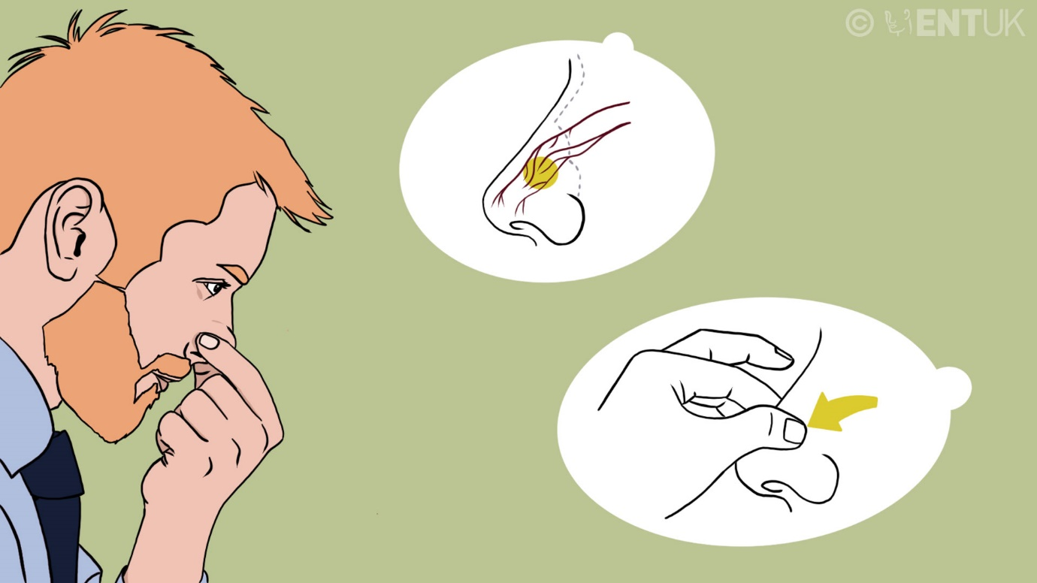

When to see your doctor
If the bleeding is severe and continues after applying pressure for 15 minutes then you need to be seen by a doctor immediately.
If the bleeding is minor, always stops with pressure but happens repeatedly, it might be more suitable to consult your own family doctor (GP) for advice.​

When can my family doctor (GP) or practice nurse treat nosebleeds?
When nosebleeds are caused by crusting and infection within the nose, your GP can prescribe an antiseptic cream. Please let the doctor or nurse know if you are allergic to peanuts or soy because one type of antiseptic cream (Naseptin) contains peanut oil. Bactroban can be used as an alternative if you have a peanut or soy allergy. This can be an effective treatment for nosebleeds, especially in children. Repeated treatments with cream for several weeks at a time may be needed. If this does not work then your GP is likely to refer you or your child to an ear, nose and throat specialist.

How do doctors treat nosebleeds?
There are a number of different ways that doctors can treat nosebleeds. In the past, doctors would have usually placed ‘packs’ of sponge or material into your nose to stop the bleeding. This often worked very well but was rather uncomfortable. Patients also had to stay in hospital for several days.
Packs are still used today but only in specific circumstances. For example, if you are taking warfarin, packing the nose is often necessary to treat nosebleeds. Under these circumstances, you may need to stay in hospital with your packs in place for a few days. Once the bleeding has stopped and your packs have been removed, the doctors will advise you on what to do about your warfarin prescription.
In most other circumstances, modern technology allows doctors to look for the bleeding point inside your nose and ‘seal it off’. This can be a fast and effective treatment for nosebleeds. ENT doctors call this ‘direct’ treatment.​
‘Direct’ treatment for nosebleeds involves ‘sealing off’ the bleeding area inside your nose. The doctor will do this by applying a chemical called ‘silver nitrate’ to the lining of your nose. This is usually done after putting some local anaesthetic solution into the nose. This procedure is not painful and can be a very effective treatment for nosebleeds.
Another ‘direct treatment’ for nosebleeds is to pass a very weak electric current across the blood vessel. This is called ‘diathermy’. This treatment is performed by ENT doctors using a small telescope inside the nose. The telescope allows the doctor to find the blood vessel that is bleeding and then use diathermy to stop the bleeding. Diathermy can also be a very successful treatment for nosebleeds and is usually performed under local anaesthetic.

Might an operation be required to treat epistaxis?
Very occasionally the treatments described above are not successful. The next option for ENT doctors is to perform an operation to stop the bleeding. There are several different types of operation than can be performed to treat nosebleeds. These procedures are quite complicated and your doctor would explain them in detail before recommending them.
ENT doctors can use telescopes and diathermy to stop bleeding from areas deep within the nose. Another operation (called sphenopalatine artery ligation) involves ‘sealing off’ the main blood vessel in the nose. This blood vessel is located behind your cheek. This operation also uses telescopes and does not usually involve making any cuts in the skin around the nose.
If the above operations are not successful then your doctor might recommend a procedure called ‘embolisation’. This involves passing small ‘guidewires’ along a blood vessel from your leg up into your nose. Radiology doctors perform this procedure and use various materials (such as fine mesh or glue) to ‘seal off’ blood vessels ‘from the inside’. This procedure is also quite complicated and your doctor will explain it in detail before recommending this treatment.

Summary
Nosebleeds can affect all ages. In most cases the cause of the bleeding is unknown. Most bleeds are relatively minor and can be treated by your family doctor. Some patients with severe bleeding may need admission to hospital. If the bleeding does not stop, or if you are on medication such as warfarin, then you may need to be seen by an ear, nose and throat specialist. ENT doctors can often stop the bleeding by cauterising the blood vessels inside the nose. In some patients with very severe bleeding an operation may be required. Your doctor will be able to explain the treatment required for your nosebleed.

Authors: Stuart Robertson and Gerald McGarry​

Disclaimer: The details in this section are for general information only. ENT UK can not assist in providing further information on the content below or booking appointments. Always check with your own doctor.
The Royal College of Surgeons
38-43 Lincoln's Inn Fields,
London WC2A 3PE
Tel: 0207 404 8373
Email: entuk@entuk.org
Registered Charity no: 1125524
Registered VAT no: 215668302

Privacy Policy Terms Cookie Policy Login
Designed & Developed by LightMedia

